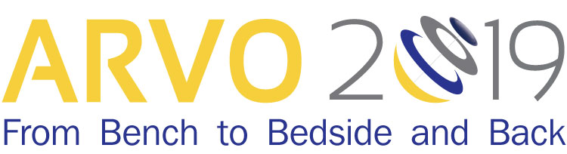

Certificate of Attendance

The Association for Research in Vision and Ophthalmology certifies that

attended the live activity titled
ARVO 2019 Annual Meeting
April 28 – May 2, 2019 | Vancouver, B.C.

